Duy Nguyen – s3878076

Lecturer: Tom Huynh

COSC2658 - IOS development

Assignment 2

# Introduction

The application I have built for assignment 2 is called GoodChess, which is a platform for users to play chess with their friends or versus a bot.

# Background

Since the topic of this assignment is to create a boardgame app, and one of my favorite projects in the past that I could not finish yet was to make a website to play chess, I’ve decided to port the project from there to create an IOS app version as a product for this assignment, and also finishing what I have started before.

# Features

GoodChess comes with a feature to play chess with a bot (singleplayer) or with a friend (multiplayer). The bot currently has 4 bot difficulties, the hardest of which gives the bot a special ability to gain an edge over its human opponent. It also gives the ability to save your previous games and watch it later. Finally, it also has a tutorial section to help newcomers to learn the basics of Chess.

# Preview

This is how the application looks upon opening:

This is the tutorial of the application, where users can learn from setting up a chessboard to how pieces move, and special rules like castling and promoting:

This is the settings view of the user, where they can edit their player name and bot difficulty. Pass To Play is a function that flips the board in multiplayer, so when the option is turned off two people can sit opposite of each other and play without having to look at inverted chess pieces.

This is the history view of the application, which shows all games that have finished. Users can also click on each game to see the final state of the board.

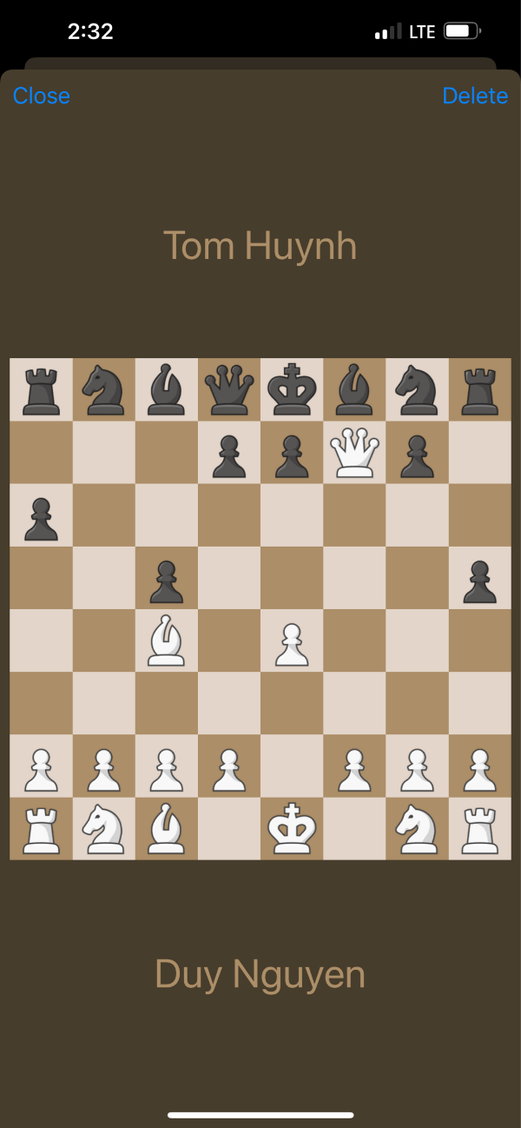

This is the play view of the game, where users can choose to either play with a bot or with a friend. Additionally, if a game has been started before, a continue button will appear to let users choose to continue the game without much effort:

This is the stage view in action, where each player takes turns making moves. If a player wants to resign early, they can hold the resignation button and the game will automatically concedes. An alert pops up to tell which player has won and to redirect the user back to the play view.

Below is a video to see the application in action:

<https://rmiteduau-my.sharepoint.com/:v:/g/personal/s3878076_rmit_edu_vn/EZTwUBqm1PhInpcR2IuQegMB_2tDxt5Y9UwoRqjt0cGQ8Q?e=zeQ9XX>

# Improvements

The application can be improved to have an online lobby to find other players and challenge them. Moreover, the game can have some achievements to push players to do interesting things to win, such as winning without losing any pawns or winning against the hardest difficulty boss. Finally, the MacOS version of the application can be adjusted to further accommodate different screen sizes, other than being a static size frame.